Application Model BOModel (Extensions visible)
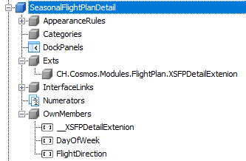
Application Model Views (Extensions not visible)
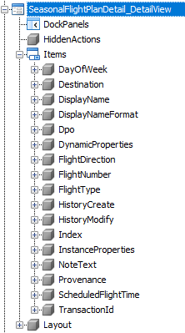
App on running Views (Extensions visible)
